**Model Optimization and Tuning Phase Template**

|  |  |
| --- | --- |
| Date | 15 July 2024 |
| Team ID | 740067 |
| Project Title | Crop Prediction using machine learning |
| Maximum Marks | 10 Marks |

**Model Optimization and Tuning Phase**

The Model Optimization and Tuning Phase involves refining machine learning models for peak performance. It includes optimized model code, fine-tuning hyperparameters, comparing performance metrics, and justifying the final model selection for enhanced predictive accuracy and efficiency.

### Hyperparameter Tuning Documentation (6 Marks):

|  |  |  |
| --- | --- | --- |
| **Model** | **Tuned Hyperparameters** | **Optimal Values** |
| KNN | --------- | --------- |
| Decision tree | --------- | ---------- |
| SVM | --------- | --------- |
| Random Forest | -------- | ---------- |

### Performance Metrics Comparison Report (2 Marks):

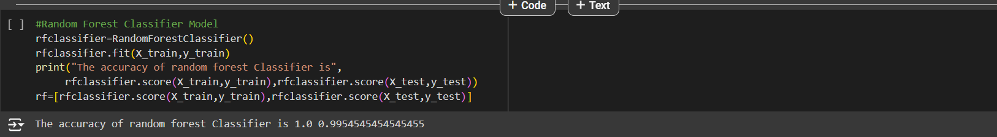

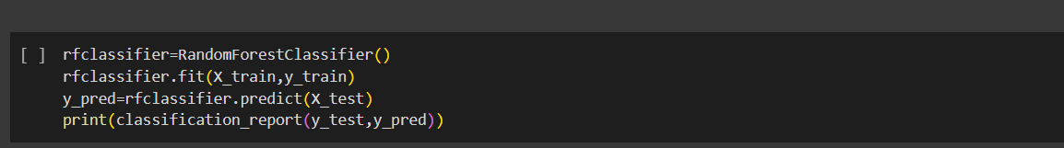

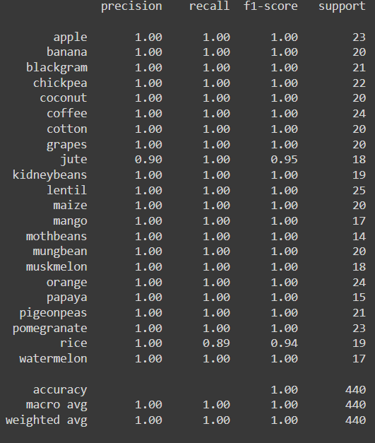

### Final Model Selection Justification (2 Marks):

|  |  |
| --- | --- |
| **Final Model** | **Reasoning** |
| Random Forest | The Random forest model usually provides high accuracy due to combining the predictions of multiple decision trees. Its ability to handle complex relationships, minimize overfitting. It can handle both classification and regression justifying its selection as the final model. |